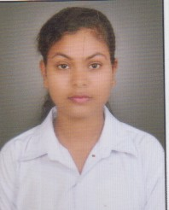
CURRICULUM VITAE
SMRUTI PRANGYA BEHERA

OBJECTIVE:-
To work in an environment which offers a good opportunity to share my knowledge and skills with others and participate myself and work towards for a complete satisfaction of the organization.
PERSONAL DETAILS:-
Father’s Name : Trinath Behera
Nationality : Indian
Date of Birth : 17th May 1996
Gender : Female
Religion : Hindu
Marital Status : Single
Languages Known : Odia, English, and Hindi

Permanent Address : AT- DEWANSAHI
PO -GURUJANGA
PS/DIST-Khordha
Odisha, India-752057

Contact No : 0091 -9315020476
EDUCATIONAL QUALIFICATION:-
- Continuing ICSI Executive Bubaneswar.
- Passed Bachelor of Commerce under Utkal University in the year 2016 with 69.00%
- Passed 10+2 Commerce under CHSE ODISHA in the year 2013 with 66.00%
- Passed 10th under BSE ODISHA in the year 2011 with 73.00%

COMPUTER SKILLS:
- Postgraduate diploma in computer application under RCSM ,Khordha .
WORKING EXPERIENCE:
- 1.5 years worked in EBIXCASH WORLD MONEY LTD., Delhi as an Executive
DECLARATION:-
I hereby declare that the above mentioned statement is correct & true to the best of my knowledge & belief.
Place:
Date: (Smruti Prangya Behera)

